Dhaka tribune

Bangladesh has had considerable human development in terms of quantity, but not in quality’
Syed Basher
Published at 03:52 pm August 26th, 2019

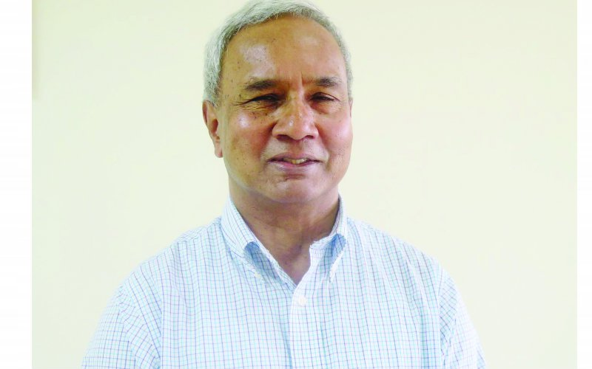
Photo: Courtesy

An Interview with Professor Salim Rashid, Professor Emeritus, University of Illinois Urbana-Champaign
Emeritus Professor Salim Rashid of the University of Illinois Urbana-Champaign has published widely in the fields of the history of economic thoughts, economic development, mathematical economics, monetary economics, Islamic economics, religion and economics, and economic methodology.
In this part of the interview, Prof Rashid answers questions on economic development of Bangladesh.
In 2008, the World Bank published a report about Bangladesh describing it as a “Development Surprise”—a combination of relatively low income per capita but high social indicators—relative to neighbouring South Asian countries such as India and Pakistan. What is your opinion on this? And how robust is this progress?
I think for such issues it is probably better to disaggregate the phrase ‘Bangladesh economic growth’ into that which the state has tried to implement and that which factors outside the state have tried to implement.
Ever since its birth, Bangladesh has been a sort of laboratory for the Western world. So, we need to ask for each particular issue, who pushed it? Was it pushed by the WHO? Was it pushed by the ICDDRB? Was it pushed by some other international body? If not, was it pushed by NGOs?
And finally, if it was pushed by the state, which government pushed it? And where did they get the funding from? If we examine and separate the motivated actors, to my mind that would form a sufficient explanation. There is no need for a general theory about this.
Let’s look at a particular development indicator: life expectancy. Bangladesh’s current life expectancy is about 72 years, which is pretty high relative to other developing countries. Was it easier to increase life expectancy due to the advancement of medicines and antibiotics?
Child mortality was perhaps the primary source of our low life expectancy before. When I was a child, life expectancy at birth was 39. That was primarily driven by high child mortality.
I think, if you look at the life expectancy of a 12-year old 50 years ago and the life expectancy of a 12-year old today, the difference would be as dramatic. It is the sharp decline in child mortality which accounts for much of our overall higher life expectancy today. Medical intervention, not economics, is to be thanked.
In 2021, Bangladesh will celebrate its 50 years of independence. How do you think the next 50 years will look like for Bangladesh? What sort of development challenges we have and how optimistic are you about the continuation of today’s economic pace in the upcoming decades?
The question is, given what path? If we just run the way we have been moving along right now, then there are several possible pitfalls. The most important is a heavy reliance on two sectors, readymade garments and remittances.
RMG is basically making use of cheap labour, but there is no reason why other people cannot offer cheaper labour. Once some other countries get themselves organized, then Bangladesh may be out of that market. It can be something that is quite sudden and in that sense catastrophic.
About overseas workers, let’s focus on those who are going overseas legally, we see an increasing trend of nationalism abroad. Therefore, these paths may soon be closed. And if they start constricting their economies within the next five years, then RMG and workers remittances can both come to a sharp fall.
If these foreign exchange sources do not continue, what does it imply about Bangladesh’s exchange rate, Bangladesh’s essential purchases, and how development can take place?
But there are other global forces. One of them is the aging of the population in the Western world. On the surface, one can argue that it will increase the demand for our workers (both skilled and unskilled). On the other hand, Western countries are increasingly relying more on automation, which may reduce the demand for workers, especially those involving routine jobs. How will these two forces affect countries like Bangladesh?
Automation is very hard to talk about because we do not know what the direction of automation will be. Or what is it that being automated. Because every species of automation is done for a specific task and we do not know which are the specific tasks which are capable of being automated right now.
So, it is better not to make any prediction of that score. But as far as aging is concerned, we have seen what happens if a country becomes sufficiently nationalistic; in Germany Angela Merkel argued that we need these workers. And a large segment of Germany said ‘no, even if we need them we do not care, we would rather be poorer and keep the country to ourselves’.
It is not automatic that, because they are aging, they will necessarily want to maintain their current lifestyle by importing workers. They might adopt a different lifestyle, so they do not need foreign workers.
These are all strategies that are based on the presumed constancy of others behaviour. They are not strategies that Bangladesh can rely upon. At some point it is better to have a number of robust paths that Bangladesh can implement by itself.
In 2000, you published a book with the title “Economic Development is Human Development.” In light of that book, how far you think countries like Bangladesh have come to develop their human resources? Put another way, what can these countries do to improve their human capabilities?
I think in quantitative term, Bangladesh has moved ahead very considerably. If you look at items like literacy per se, there has been a huge increase in literacy and a spectacular increase in female literacy. If you look at it in terms of quality, then the problem arises.
Until we can ensure that quality catches up with the quantitative increase, the measured increase may be something of a mirage.
On the other hand, the recognition that human capital in education must be acquired is visible everywhere. Even the lowest paid workers (eg, drivers, rickshaw pullers), are very concerned that their children need an education in order to get ahead. And they make enormous sacrifices so that their children can get one rank higher.
This implicit demand is so great that if the state can structure the education system better, I am sure that there will be very rapid improvement in quality.
So you’re implying that we are in a position to estimate the returns to education?
Even without a systematic estimate, I think the return to education is very high in the perceived calculus of parents. And this is very high for two reasons. In and of itself, if you can become a reasonably competent graduate, your income level and your potential future earnings increase enormously.
And secondly, I see most parents consider their number one option for their children is to go abroad, whether boy or girl; does not matter. Even if the Western world closes its borders for the unskilled, they will still leave them open for the educated, because they create the least problems and provide the greatest benefits to the West.
In their own interest, they will keep the educated channel open. This is the flow that can be sustained. But it needs proper direction. If the quality is not there, nobody will care about who is being educated.
Researchers claim that Bangladesh has not experienced the demographic transition. So, unless Bangladesh crosses the demographic transition, it will not be able to increase its per capita income. Which in turn implies that the quality of human capital will not be much improved either.
My understanding of the situation is somewhat different. What the demographic transition used to say is that first your income rises, then you reduce your family size. Bangladesh surprised everybody by reducing its family size even before its income rose.
But the initial momentum was not being sustained. And now there seems to be a slackening in the growth of population control (or population planning).
In a sense, we have ‘broken’ demographer’s expectations in two ways. One, population growth declined before income increased; and subsequently, as income increased, population growth has started again.
This needs better study. The population is one of those areas where abstractions are pointless. The best way you find out whether or not people will have more children is not to run regressions but to go and ask the parents. We need to get micro-level studies on parents’ motivations for family size. Only then can we find out the way to tackle the issue.
Syed Basher is Associate Professor of Economics at East West University. He can be reached via syed.basher@ewubd.edu

