https://www.dhakatribune.com/

The dream of a top 10 Bangladeshi private university appears just as distant as before’
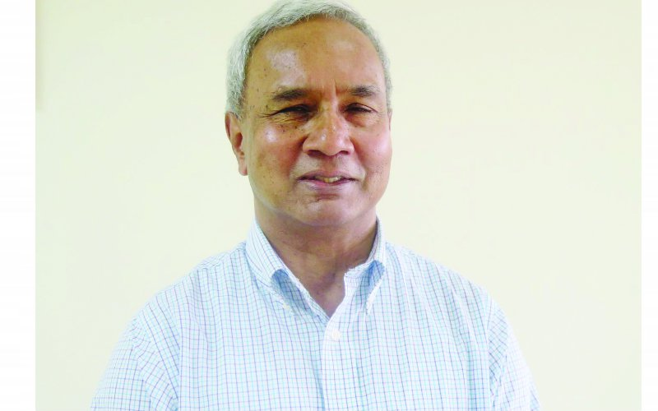
Syed Basher
Published at 07:39 pm September 8th, 2019

Courtesy

An Interview with Professor Salim Rashid, Professor Emeritus, University of Illinois Urbana-Champaign
Emeritus Professor Salim Rashid of the University of Illinois Urbana-Champaign has published widely in the fields of the history of economic thoughts, economic development, mathematical economics, monetary economics, Islamic economics, religion and economics, and economic methodology.
This is the final part of the four-part interview with him. In this part, Prof Rashid answers questions on higher education, income inequality and other related topics.
You were involved in the development of the “private university industry” in Bangladesh in its early days. After twenty five years of its existence, how far you think the private university sector has come? Did it meet your expectations?
As with our earlier discussion on education, the quantity response has been overwhelming and the quality control disappointing.
The dream we had in 1990 of producing a Bangladeshi private university to rank in the top ten in Asia appears just as distant as before.
There exists a considerable bias about private universities in Bangladesh. One of my students at East West University is subject to bullying by her own family members as inferior quality, compared to her brother who is a student of BUET. Similar bias also persists among employers (private and government alike) when hiring graduates from private university, who often face unfair and unequal treatment vis-à-vis their public counterparts. What are the likely consequences of this bias to our society and how to deal with it?
The fate of such students is unfortunate. But the systemic fault lies with the private universities. The public cannot distinguish among such a large number; they must be helped by the private universities insisting on accreditation. As private universities, they must engage in more systematic liaison with the private sector so that their value is recognized.
Why could not any public or private university become a research-oriented university in Bangladesh? We can also find an almost similar situation in South Asian countries. What seems to be the root causes of this underdevelopment?
As far as Bangladesh is concerned, the answer lies in the same malaise that seems to underlie many aspects of public life – the readiness to grab short-run profit, even at the expense of a greater long-run gain.
How is higher education different today from your days as a student and in what different direction will it evolve in the coming decades?
Research was not much thought of then. That was left to the whites. So, there is undoubted gain in our self-confidence today.
However, the faculty are paid less in real income, have less societal respect and, perhaps in consequence, are much less dedicated to teaching. Students, on the other hand, are extremely fortunate.
My parents were well to do, and yet, I cannot tell you how hard it was to get a good textbook—forget about journals or other aids to study. The hours we wasted going from place to place searching for a book! Today, you can get a MIT course online for free—and every imaginable topic is at one’s fingertip on the web.
Let me turn to the question of income inequality. You seem to have a different perspective on income inequality than what we hear in the popular media or read writings by accomplished researchers. Could you elaborate your views on income inequality?
We need to acquire wealth before we can redistribute it. Right now, we are insufficiently focused upon the means to attain 10 percent growth. If we grow rich in the proper way, and attain 10 percent growth, the redistribution will take care of itself.
Equality under the market is an impossibility because markets work by punishing failure. For a society to withstand and grow from such failure, it needs strong non-economic bonds.
We can and should worry about poverty, but inequality is a part of Capitalism. What is needed is the social framework which assures justice and opportunity—the resultant inequality will be acceptable.
How do you assess the recent emphasis on unconditional basic income as a means to deal with income inequality?
I may not understand the proposition, but if it is as stated, then its proponents must believe that people work even if they do not need to.
For over twenty years, you are promoting the idea of “compact township” (CT) to provide a comprehensive alternative to housing, infrastructure, employment and more for the general population. What lessons you have learned regarding promoting a development idea in Bangladesh and what is the status of your CT project?
The most important lesson that I have learned is the great divide between the elites in Dhaka and the ordinary people in the villages. After ten years of meetings, seminars and presentations I got only a pat on the back.
In 2008 I decided to start talking to villagers across a wide swathe of Southern Bangladesh. To my delighted surprise, many of them anticipated the CT idea. Hence, members of the Compact Township Foundation, particularly Dr Abul Hossain and Mr Ekram Hossain, have tried to focus their efforts outside Dhaka.
Fortunately, we attracted the attention of a Bogra developer, Mr A Karim, who has convinced the people of Khorna about the necessity of land pooling for a CT. Now the next step is for us to develop the legal and financial infrastructure to make these wishes effective.
Do you have professional regrets and ambitions?
Economics is a fascinating and important subject. I greatly regret the way in which it has abdicated its interdisciplinary importance by insisting that it is a ‘science’.
Thank you, Prof Salim Rashid.
Thank you.
Syed Basher is Professor of Economics at East West University. He can be reached via syed.basher@ewubd.edu

