Minutes

Participatory Discussion meeting on Compact Township
Place: Hai Waheed- Morium Hon’s College, Chandaikona, Raygonj, Sirajgonj
Date: 20 June 2014
Organized by Compact Township Foundation and Muktojibon
1. A participatory discussion-meeting on Compact Townships was held on 20 June 014 at the Haji WaheedMorium Hon’s College of RoyganjUpazila under the Sirajganj district. The organizers of this discussion meeting were compact Township Foundation(CTF) and Muktajibon(an informal organization for bio-diversity and environment).
2. At the very outset, journalist Dipak Kumar Kar, President of Raygonj Upazila Press Club, welcomed all the participants in the meeting. The participants were from different walks of life such as principals, vice-principals and professors of different colleges, Head-masters and teachers from different schools, Imam, Journalists, farmers representatives, women’s representatives, students from college and universities and general members of Muktojibon. They all come braving the rain. Mr. Dipak Kumar expressed his gratitude to all for theircoming despite the weather.
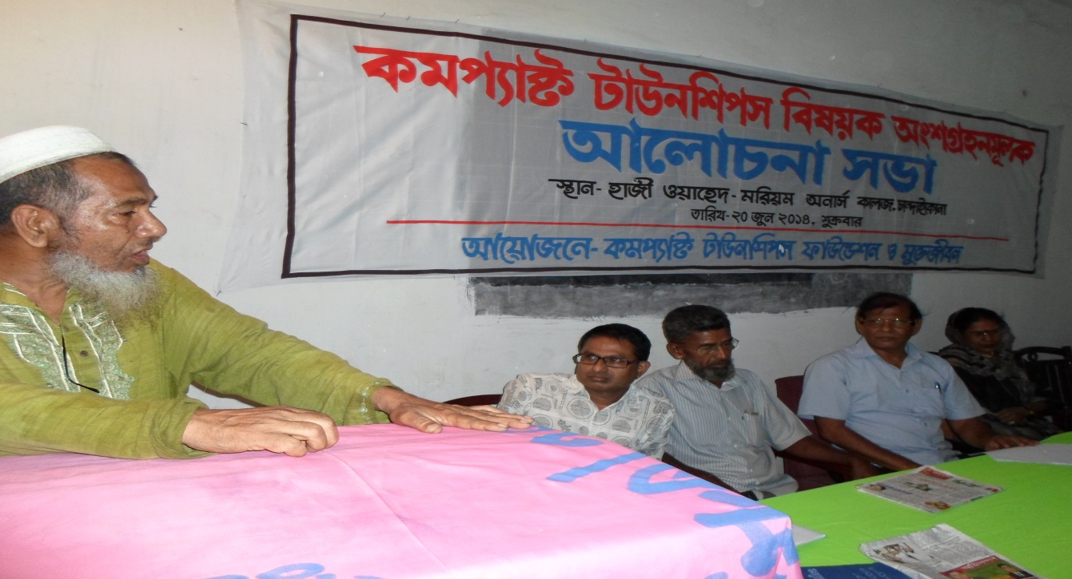
3. The meeting was presided over by the General Secretary of Muktojibon- Mr. Khorshed Alam. Dr. Abul Hossain – General Secretary of Compact Township Foundation(CTF) was present as the Chief Guest. As Special Guests in the meeting were present former Principal Shamsul Haque, Principal Golam Mustofa, Vice-principal Hasina Morshed, Motiur Rahman BSC., etc.
4. First, Mr, Ekram Hossain of BRAC university, also a core member of the Compact township Foundation delivered his speech and took charge of conducting the program. Then Dr. Abul Hossain gave an introductory speech on Compact Townships and the Compact Township Foundation. He told the meeting that Compact Townships was not a new concept. He said, “For the last 20 years we have been thinking and talking about it and carrying out different activities. We‘ve gone different areas of the country and also came here to let the people know about it. We came to hear your opinion and learn from you. Research shows that annualy1% of agro-land is lost . If this trend continues, there will be no arable-land in the country by 2050 or so . How this problem would be solved, how we can live well---- that’s why the Compact Township concept arrived.” In a compact township, all desirable facilities will be available-- amenities such as -schools, hospitals etc will be there. We are not thinking about Compact townships in big cities and towns. It can be implemented anywhere, even in villages. Compact townships (CT)may be developed as per the local characteristics, such as where the area is agro-based, compact township may be developed to match; and where there is Fishing , CT can be developed based on to suit.
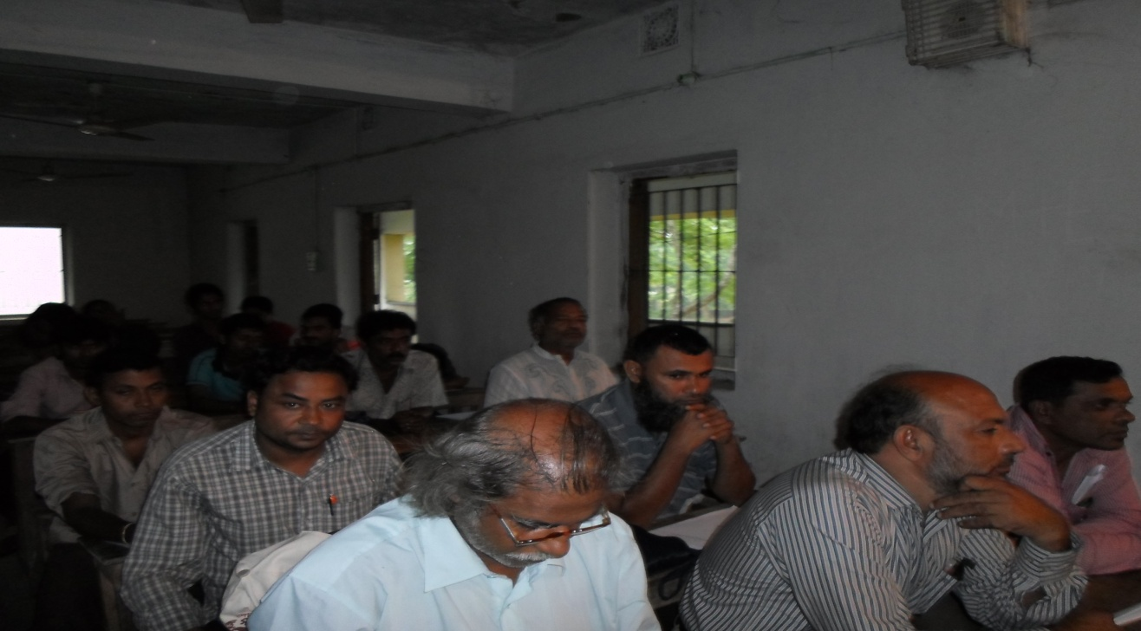
5.As it was Friday, the discussion-meeting was divided into two sessions. After the speeches of the first session, some speeches continued into second session for a while. And then the house was declared open where everybody participated in the open-discussion spontaneously.
The following views, opinion and recommendations emerged from the discussion:
- Whether Compact townships will remain on paper only or it will see the light of implementation;
- Members can be made through giving forms in exchange of Tk. 5-10. Members can monitor the numbers who join, who becomes members and how many are ready to be members, and how others respond about the concept of CT.
- The Campaign should be enhanced because publicity will create growth.
- The government needs to think about CT’s for good governance.
- This concept should be publicized in school and colleges .
- Before a bigha of land grew only 5-7maunds of rice, now 50 maunds is possible. We’ve also heard that floods will not be able to affect new varieties of rice. But if agro-lands vanish, where will these be cultivated? What we did not to believe earlier, now are being done by utilizing the internet. Compact Townships will also reach its target.
- What is position of constitutionally responsible persons? What is the government thinking?Government also has to read the pulse of people.
- Selfishness makes people mad.
- NGOs may be involved in implementing this idea?
- The person whose income is lakh taka, how will he live in the CT?
- We can engage volunteers for this purpose.
- Compact Township means a place where we can be self-dependent.
- Without government, it may not be implemented.
- For electricity in the CT bio-gas and solar system may be used.
- In a CT, those who are rich will not allow the poor like us. Though they talk well, but if they find any obstacle to their interest, they themselves will create problems. Those who have money want to maintain status.

